metin, yazı tipi, grafik, grafik tasarım içeren bir resim

Yapay zeka tarafından oluşturulan içerik yanlış olabilir.

**SE-212 HUMAN COMPUTER INTERACTION**

**TERM PROJECT REPORT**

Project Name: Turbo Cargo

Instructor: Kerem AY

Group Number: A-7

Members:

Atacan İSHAN

Arda DEMİR

Baran Kemal YAZICI

Çoruh Sarp ACAR

**Table of Contents**

**1.** **Similar Websites / Apps That Already Exist** 3

**2.** **Target Population** 4

**3.** **Key Functional Requirements of the System** 5

**4.** **In-App Interface Screenshots** 8

**4.1 Pages for Mobile Devices** 8

**4.2 Pages for Web** 12

**6.** **User Testing and Evaluation** 20

**Observation Sheet (WEB) – User 1** 20

**Observation Sheet (WEB) – User 2** 21

**Observation Sheet (WEB) – User 3** 22

**Observation Sheet (WEB) – User 4** 23

**Observation Sheet (WEB) – User 5** 24

**System Usability Scale (WEB) – User 1** 25

**System Usability Scale (WEB) – User 2** 27

**System Usability Scale (WEB) – User 3** 29

**System Usability Scale (WEB) – User 4** 31

**System Usability Scale (WEB) – User 5** 33

**A/B Test – User Preferences** 35

# **Similar Websites / Apps That Already Exist**

We investigated and analyzed two existing shipping systems: Yurtiçi Kargo and Aras Kargo. Both shipping systems have a cargo tracking feature that informs the user of the location of the cargo. There is a user login option in both systems, but it informs us about the cargo without logging in. Both Aras Kargo and Yurtiçi Kargo claim to make it easier to return the cargo. Unlike these systems, our cargo system will have a delivery verification feature with instant photo. At the time of delivery, the courier will take a photo proving that the cargo has been delivered and upload it to the system. With this application, we will solve customer trust issues. It will also increase customer satisfaction.

**References:**

* **Yurtiçi Kargo:** [**https://www.yurticikargo.com**](https://www.yurticikargo.com)
* **Aras Kargo:** [**https://www.araskargo.com.tr**](https://www.araskargo.com.tr)

# **Target Population**

**Age Range: 18-45**

* The system is mainly targeted at adults who are interested in technology and frequently shop online.

**Profession:**

* **Online Sellers:** Online sellers will need a shipping system to deliver the product they sell to the customer.
* **Couriers:** They will both contact the customer through the system if necessary and upload a photo of the cargo delivery to the system.
* **Online Shoppers:** They will use our system because they want to receive delivery of their product in a transparent and reliable way.

**Gender:**

* The system is gender-neutral and inclusive of all gender identities.

**Education Level:**

* Users are expected to have at least a high school education to minimize the difficulties they will experience while using technology and shopping online.

# **Key Functional Requirements of the System**

* Meeting user needs and providing competitive service, the Turbo Cargo system includes the following basic functions. Every feature is designed to provide straight and fluent shipping experience, from account setup to delivery confirmation and post-delivery registrations.

1. **Account Management (User & Courier Login/Registration):**  
   The system must support secure account creation and login for both customers and couriers. New users will register using email, password, and contact details. Also, couriers can register themselves. After logging in, users can access their shipping control panel, including active deliveries and order history. Couriers will see their assigned job lists. Only authorized users can view or manage shipment information. Features such as password recovery and error messages support a clean user experience.
2. **Live Package Tracking:**  
   Turbo Cargo needs to offer real-time package tracking. Users can enter a tracking number or select a shipment from their account to see the live status. The system displays the status of the delivery, such as "Package Accepted", "In Transit", "Out for Delivery" and "Delivered". When a package is out for delivery, the map can show the courier's real-time location. Status updates are automatically refreshed at regular periods. Visual tools like progress bars and map markers help users easily track the shipping process.
3. **Photo-Based Delivery Confirmation:**  
   The system will support photo confirmation for every delivery. When a courier finishes the delivery, the app will ask them to take a picture of the package. The photo can be at the door or when they give it to the person. This image will be uploaded, timestamped and if possible GPS tagged. Users will see the photo in the tracking view and shipment history. This visual confirmation helps solve delivery disagreements and builds confidence by proving that the product has reached its planned destination. For couriers, the interface will be optimized for quick access to the camera and easy photo sending.
4. **Notification System:**Turbo Cargo will automatically notify users about important shipping events. When the package is picked up, moved, or delivered, the user gets a message. Sometimes also if there is a delay. Messages can come in the app, email, or SMS, depending on what the user chooses. For example, the user can see: “Your package will come at 5 PM” or “Delivered - see the photo.” This way users don’t need to check the app all the time. They know what happens with their pack. Messages are simple to understand. Users can also change settings if they want fewer or more alerts. These alerts ensure that users stay up to date without having to manually check the app. Notifications will be sent in simple language and at the appropriate time. Users can also customize which types of alerts they want to receive.

1. **Order History & Shipment Records:**Each user will have access to their full shipment history with their account. This includes shipment dates, locations, delivery statuses, delivery times, and confirmation photos. Users can classify or filter the list, for example, displaying only completed deliveries or returns. The interface will display this information with known icons (e.g., checkmarks for delivered, arrows for transit) to help users quickly understand the status of each shipment. Using standard visual marks and terminology supports quick recognition and creates consistency across the platform.

* Conclusion:  
  These five core functional requirements enable Turbo Cargo to deliver a modern, reliable and user-centric delivery experience. From account setup to final delivery, every part of the system is designed with clarity, control and ease in mind. Real-time tracking, photo-based confirmation and personalized notifications provide a transparent and secure service that meets current market standards and increases customer confidence.

# **In-App Interface Screenshots**

## **4.1 Pages for Mobile Devices**

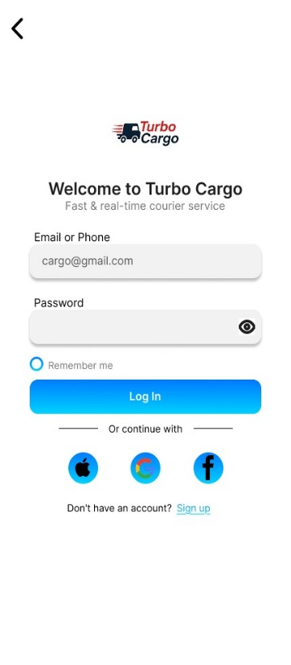**Log In Page**

* We have an interface created with a black and blue theme on a white background color. The company's logo is positioned at the top and in the middle of the screen and below it is a slogan of the company. Underneath, there is a section where you can log in by e-mail or phone number, and if you want to log in quickly, you can log in through different options. (For example, Facebook, Google, Apple) There is also a button to switch from this section to a page where you can sign up for a new account. There is a round button that saves you from logging in again and you need to click.

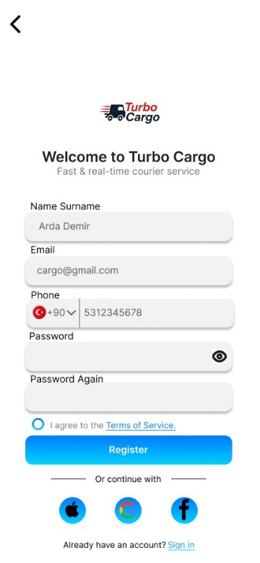**Register Page**

* This screen is very similar to the previous screen design, with boxes that allow us to collect the information needed to create a new account and boxes with sample input information that tells the user how to enter their information more accurately. If you already have an account, we have made sure to highlight the clickable areas on this screen where there is a login button to quickly sign in and there is a round button where you need to accept the shipping agreements.

**Main Page (A)**

* This screen is designed to track where your cargo is after you have logged in to your account. There is 1 box where you can enter your cargo tracking number, and below it is a click button. Following that, there is a history section where you can view your past and current shipments. At the bottom, there is a redirect to the page where you can provide the necessary information for a cargo you need to ship somewhere.

**Main Page (B)**

* 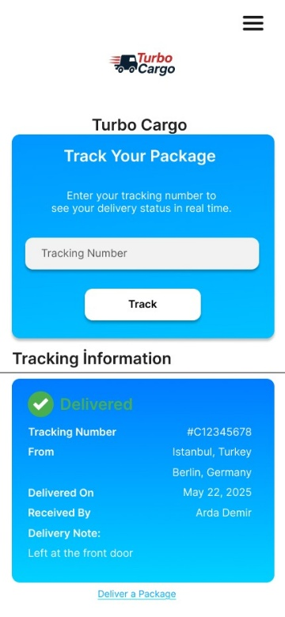This screen is a second version of the main page. Unlike the other main page, we can see the information of the cargos in the history section in more detail on this screen. Similarly, there is a redirect that needs to be clicked to ship a cargo somewhere, and a section where you need to enter your cargo tracking number to track your cargo.

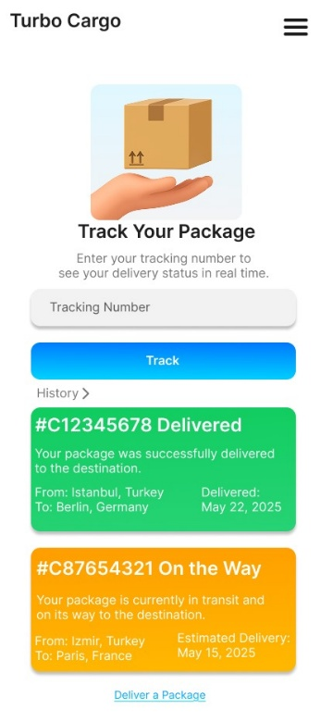

**Cargo Delivered Page**

* This screen will appear after your cargo has been delivered. There is a text indicating that your cargo has been delivered. Detailed information about your cargo is shown in a box. The address where the cargo was delivered is shown on a map. There is a text where you can see the delivery time. There are buttons where you can download the receipt and track a different cargo.

**Deliver a Package Page**

* 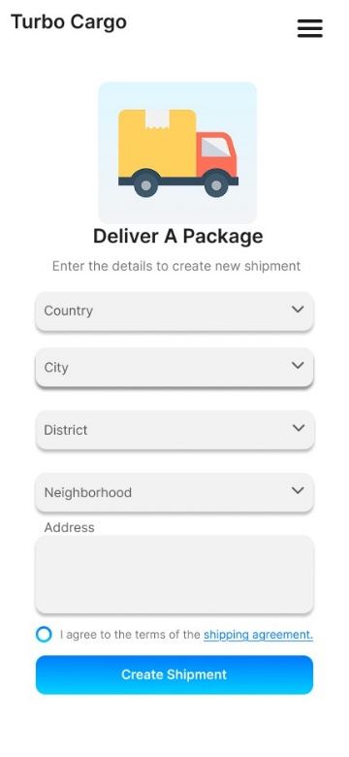This screen appears when you click on the Deliver a Package redirect on the main page and is the screen where you can enter all the information required to ship a cargo to a location. You will be able to enter your address through the options so that you can quickly enter general address information. There is also a text box in case you want to write your full address in detail. There is a round button with the shipping agreement that you need to accept.

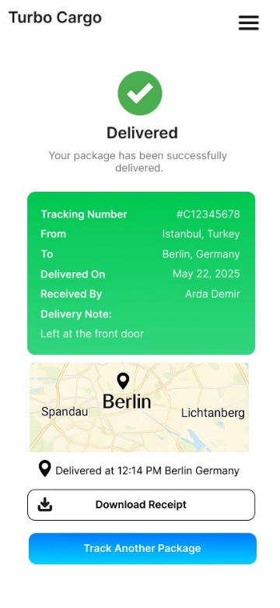

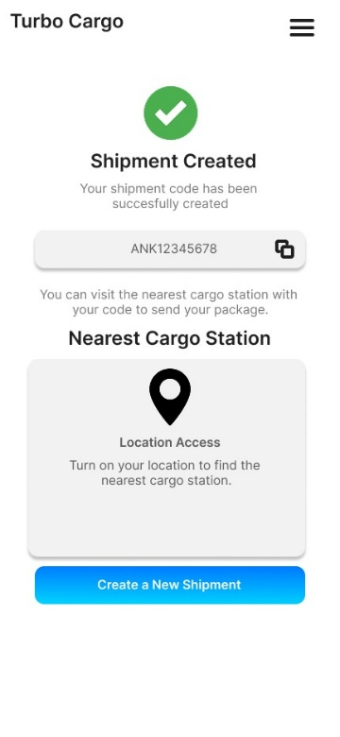**Package Created Page**

* This is the screen that will appear after you create a cargo. There is a text on the screen informing you that your shipment request has been successfully created, and below it is the shipment code. For those who want to copy this code, there is a copy button on the right side of the code. To ship your cargo with the given shipment code, there is a map showing the nearest cargo station. At the bottom, there is a button to click if you want to create a new shipment.

## **4.2 Pages for Web**

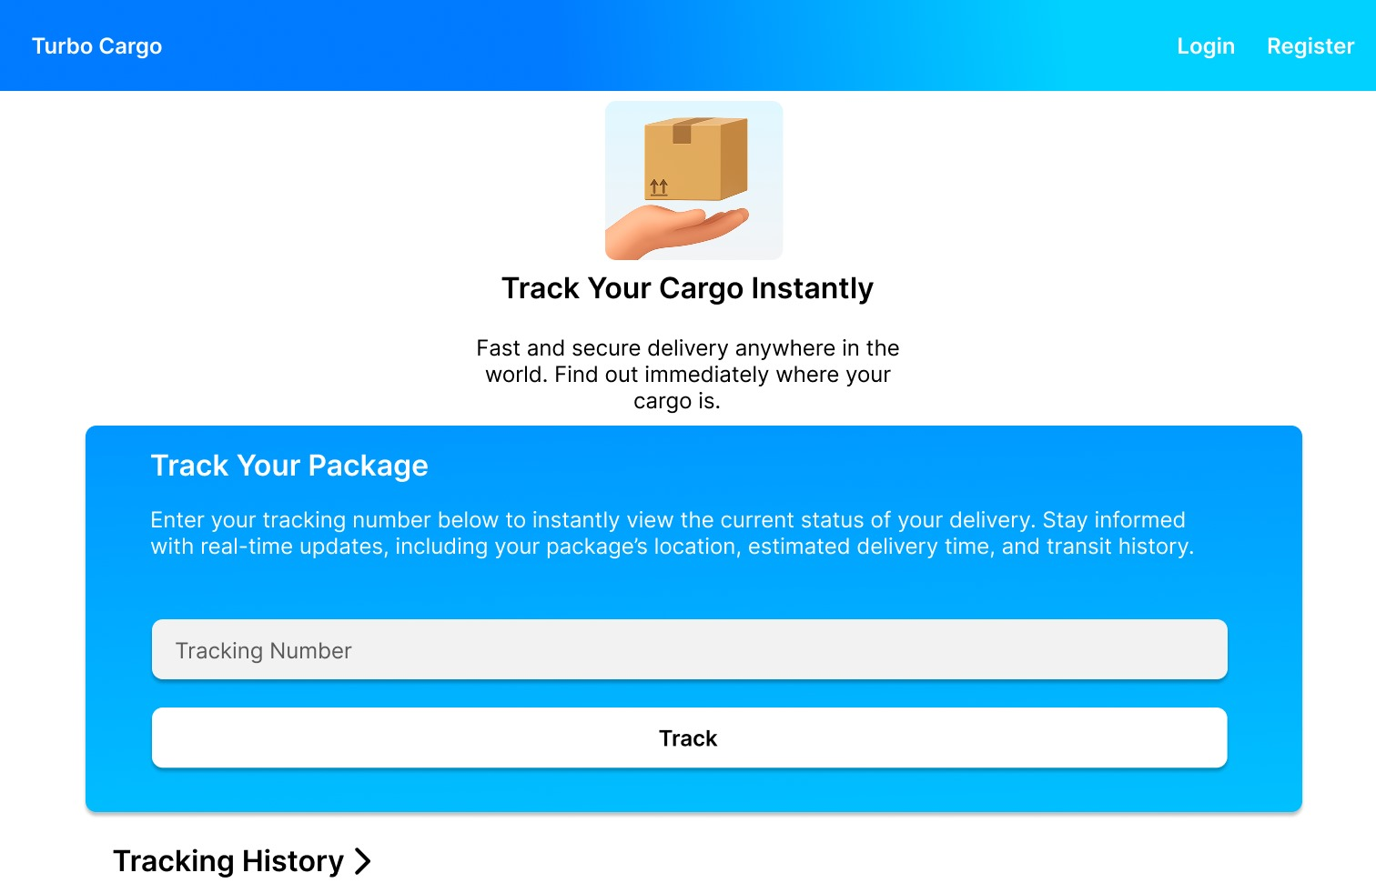

**Main Page (A)**

* On this screen, the name of the company is at the top left. There are login and register buttons on the top right. In the center of the page, there are inscriptions stating that our company offers a good service to users, and just underneath, there is an area to track your cargo. After users enter their own numbers in the tracking number section in this area, they perform the tracking process with the button below. At the bottom, there is a section for them to track their past shipments.

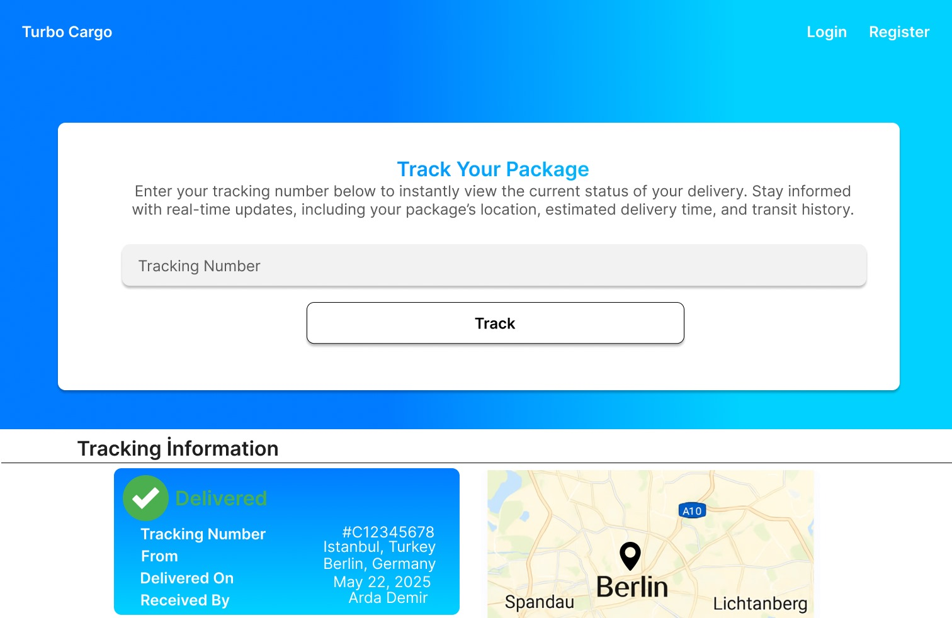

**Main Page (B)**

* This page is an alternative main page. In the same way, there is the company name on the top left and login and register buttons on the top right. After entering the tracking number in the tracking number section in the box that covers most of the screen, users can track their cargo by pressing the button below. At the bottom of the page is the tracking information section. In this section, we can see the details of old cargoes and the locations where they were delivered on a map.

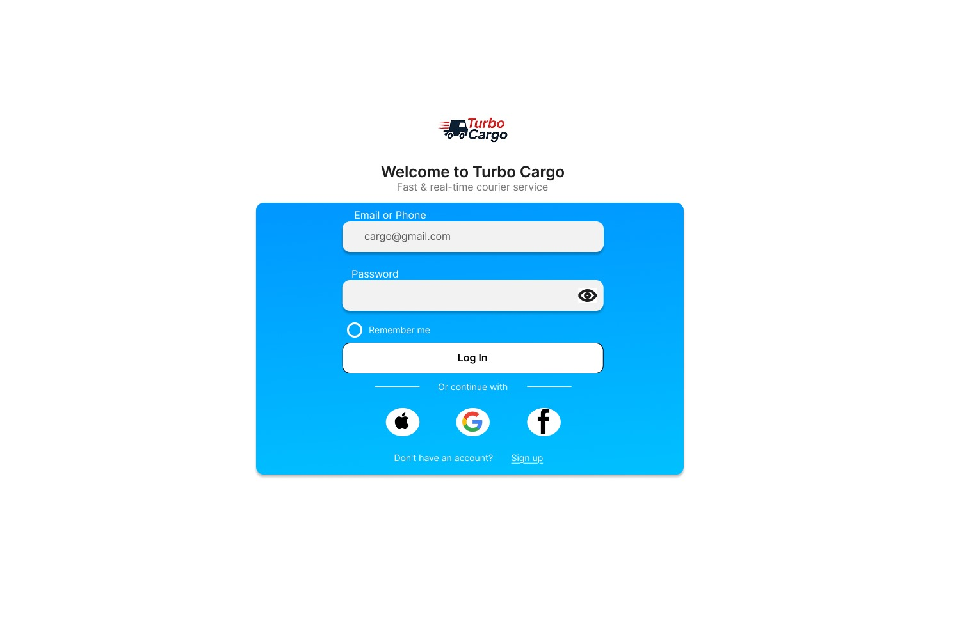

**Login Page**

* In the center of the screen is the company logo. There is a section that welcomes the user and states the slogan. Just below it, there are sections where the user can write their login information. There is a button for users who want to see their password while typing. There is a “Remember Me” button so that the user does not need to log in to the site again. Just below it, there are buttons that allow them to log in quickly from different platforms (e.g., Apple, Google, Facebook).  
  At the bottom, if you don't already have an account, there is a button that directs you to the registration page.

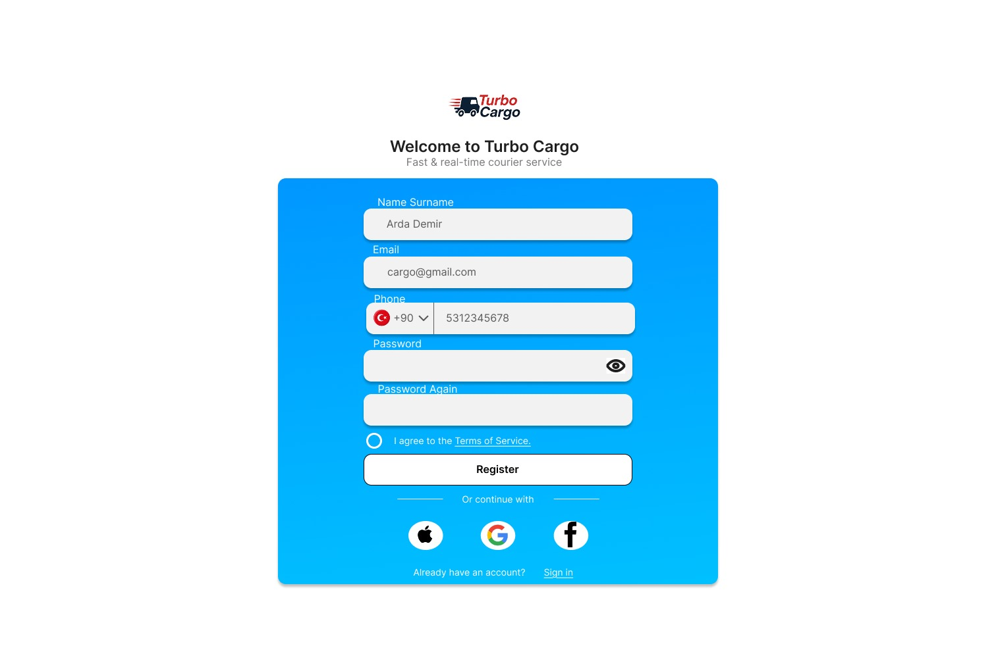

**Register Page**

* At the top of the screen, there is the company logo, and below it, the slogan. Underneath, there are boxes where the user can enter the information they need to register. In each box, there are instructions on how to enter the information correctly. There is a selection box to choose which country the phone number belongs to. There is a circular button to accept the Terms of Service. Underneath, there is a “Register” button. For users who want to register quickly, there are buttons with different platforms (e.g., Apple, Google, Facebook). At the bottom, there is a button that sends users who already have an account to the login screen.

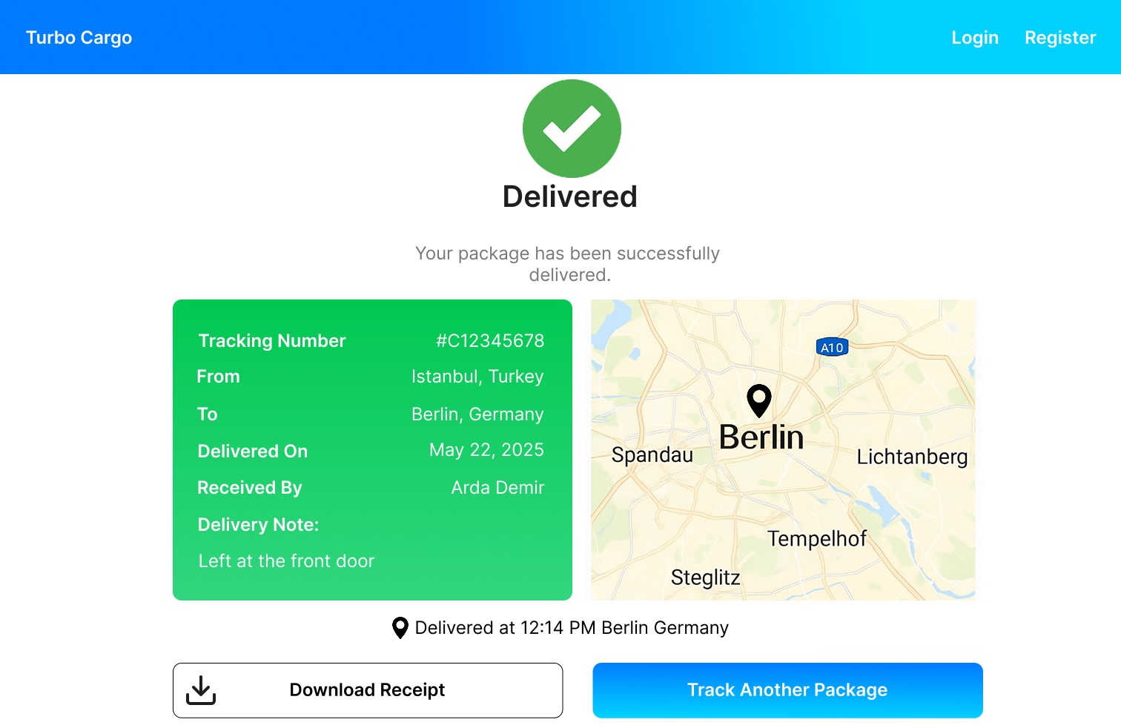

**Cargo Delivered Page**

* At the top left of the screen is the company name. There are Login and Register buttons on the top right. In the center of the screen, there is a text that says the cargo has been delivered. Underneath, there is detailed information about the cargo and a map showing where the cargo was delivered. Below that is the time when the cargo was delivered. At the bottom of the screen, there is a button to download the receipt and a button to track another package.

The FIGMA link including our interfaces is provided below:

<https://www.figma.com/design/hOM7KBQIUTvPvVdKQqc2L0/Cargo?node-id=20-48&t=GtF9L8M8QTFEYUzw-1>

1. **Design Principles Used in Our Interfaces**

|  |  |  |  |
| --- | --- | --- | --- |
| Principle | Page Titles for Mobile | Page Titles for Web | Student Name |
| Hick’s Law,  Fitts’s Law,  Nielsen Principles: Visibility, Aesthetic  Gestalt Principles:  Proximity, Continuity | Main Page | - | Atacan İSHAN |
| Hick’s Law,  Gestalt Principles:  Proximity, Continuity  Nielsen Principles: Visibility, Aesthetic | Main Page B | - | Arda DEMİR |
| Nielsen Principles:  Help users recognize, Consistency | Login | - | Çoruh Sarp ACAR |
| Nielsen Principles:  Help users recognize, Consistency, Error prevention | Register | - | Çoruh Sarp ACAR |
| Nielsen Principles:  Help users recognize, Error prevention | Deliver a Package | - | Arda DEMİR |
| Nielsen Principles:  Visibility, Match between system, Error prevention | Deliver a Package Created | - | Arda DEMİR |
| Fitts’s Law,  Nielsen Principles:  Visibility, Match between system, Aesthetic and minimalist design | Cargo Delivered Page | - | Baran Kemal YAZICI |
| Fitts’s Law,  Nielsen Principles:  Help users recognize, Visibility, Match between system and the real world,  Gestalt Principles:  Proximity & Grouping | - | Main Page | Atacan İSHAN |
| Hicks’s Law, Fitts’s Law Aesthetic-Usability Effect,  Fitts’s Law  Place Important Items at Top Center,  Gestalt Principles:  Proximity & Grouping  Nielsen Principles:  Help users recognize, Flexibility and efficiency of use,  Universal Design Principles:  Perceptible Information | - | Main Page B | Baran Kemal YAZICI |
| Fitts’s Law,  Universal Design Principles: Simple and Intuitive Use, Low Physical Effort  Nielsen Principles:  Help users recognize | - | Login | Arda DEMİR |
| Nielsen Principles:  Help users recognize, diagnose and recover from errors, Consistency and standards  Universal Design Principles:  Simple and Intuitive Use, Low Physical Effort | - | Register | Atacan İSHAN |
| Fitts’s Law,  Nielsen Principles:  Visibility of system status, Match between system and the real world, Flexibility and efficiency of use,  Universal Design Principles: Low Physical Effort  Gestalt Principles:  Proximity, Continuity | - | Delivered Page | Baran Kemal YAZICI |

We used around 15 design principles in designing this interface. The principles are as follows:

1. Visibility of system status,
2. Match between system and the real world,
3. Consistency and standards,
4. Help users recognize, diagnose and recover from errors,
5. Error prevention,
6. Flexibility and efficiency of use,
7. Aesthetic and minimalist design,
8. Proximity,
9. Continuity,
10. Perceptible Information,
11. Simple and Intuitive Use,
12. Low Physical Effort,
13. Fitts’s Law,
14. Hicks’s Law,
15. Placing Important Items at Top Center.

# **User Testing and Evaluation**

## **Observation Sheet (WEB) – User 1**

|  |  |  |  |  |
| --- | --- | --- | --- | --- |
| Task | Start Time | End Time | Notes | +/- |
| Signing in new account. | 00:00:00 | 00:00:45 | Completed quickly without issues | + |
| Login to the system using email and password. | 00:00:45 | 00:01:05 | Logged in on first try | + |
| Create a new cargo shipment. | 00:01:05 | 00:02:05 | Shipment form easy to navigate | + |
| Enter recipient details (name, last name, address, phone number). | 00:02:05 | 00:02:55 | Recipient details accepted immediately | + |
| View and confirm the shipping cost. | 00:02:55 | 00:03:10 | Shipping cost displayed clearly | + |
| Logging out from the system. | 00:03:10 | 00:03:20 | Logout smooth | + |

## **Observation Sheet (WEB) – User 2**

|  |  |  |  |  |
| --- | --- | --- | --- | --- |
| Task | Start Time | End Time | Notes | +/- |
| Signing in new account. | 00:00:00 | 00:00:50 | Verification email arrived promptly | + |
| Login to the system using email and password. | 00:00:50 | 00:01:15 | Password mask helpful | + |
| Create a new cargo shipment. | 00:01:15 | 00:02:10 | Accessible via shortcut | + |
| Enter recipient details (name, last name, address, phone number). | 00:02:10 | 00:02:50 | Autocomplete assisted recipient details | + |
| View and confirm the shipping cost. | 00:02:50 | 00:03:10 | Real‑time cost update visible | + |
| Logging out from the system. | 00:03:10 | 00:03:22 | Logout completed easily | + |

## **Observation Sheet (WEB) – User 3**

|  |  |  |  |  |
| --- | --- | --- | --- | --- |
| Task | Start Time | End Time | Notes | +/- |
| Signing in new account. | 00:00:00 | 00:01:00 | Minor delay in email delivery | + |
| Login to the system using email and password. | 00:01:00 | 00:01:35 | Required two login attempts | + |
| Create a new cargo shipment. | 00:01:35 | 00:02:07 | Menu icons clear | + |
| Enter recipient details (name, last name, address, phone number). | 00:02:07 | 00:02:21 | Correct tracking number format accepted | + |
| View and confirm the shipping cost. | 00:02:21 | 00:02:30 | Status loaded without reload | + |
| Logging out from the system. | 00:02:30 | 00:02:36 | Logout button easy to find | + |

## **Observation Sheet (WEB) – User 4**

|  |  |  |  |  |
| --- | --- | --- | --- | --- |
| Task | Start Time | End Time | Notes | +/- |
| Signing in new account. | 00:00:00 | 00:00:55 | Form validation worked well | + |
| Login to the system using email and password. | 00:00:55 | 00:01:17 | Auto-login prompt appeared | + |
| Create a new cargo shipment. | 00:01:17 | 00:02:15 | Responsive design good | + |
| Enter recipient details (name, last name, address, phone number). | 00:02:15 | 00:02:52 | Input mask prevented errors | + |
| View and confirm the shipping cost. | 00:02:52 | 00:03:08 | Detailed shipment history shown | + |
| Logging out from the system. | 00:03:08 | 00:03:17 | Logout process smooth | + |

## **Observation Sheet (WEB) – User 5**

|  |  |  |  |  |
| --- | --- | --- | --- | --- |
| Task | Start Time | End Time | Notes | +/- |
| Signing in new account. | 00:00:00 | 00:00:40 | Account created in under a minute | + |
| Login to the system using email and password. | 00:00:40 | 00:00:58 | Smooth login experience | + |
| Create a new cargo shipment. | 00:00:58 | 00:01:50 | Clear navigation path | + |
| Enter recipient details (name, last name, address, phone number). | 00:01:50 | 00:02:23 | Quick acceptance of recipient details | + |
| View and confirm the shipping cost. | 00:02:23 | 00:02:37 | Table layout easy to read | + |
| Logging out from the system. | 00:02:37 | 00:02:44 | One-click logout | + |

**Observation Report and Comment:**

Users generally completed tasks in the system successfully. Operations such as "logging in", "logging out" and "viewing shipping costs" were completed quickly and smoothly. Average task times indicate a user-friendly experience. All users found the interface understandable and the instructions adequate. Minor delays were only experienced during the registration process, but this did not significantly affect the mission’s success. In conclusion, the system was found to be both effective and efficient, and users completed tasks with ease. Apart from minor improvements, the overall user experience was evaluated positively.

## **System Usability Scale (WEB) – User 1**

|  |  |  |  |  |  |
| --- | --- | --- | --- | --- | --- |
| Statement | 1 | 2 | 3 | 4 | 5 |
| 1. I easily found the tracking feature without needing instructions. |  |  |  |  | X |
| 2. I feel confused by the amount of information or options. |  |  |  |  | X |
| 3. I felt satisfied with the speed and responsiveness of the website. |  |  |  |  | X |
| 4. I didn't know where to click or what to do next. |  |  |  | X |  |
| 5. I think new users can understand this system without much effort. | X |  |  |  |  |
| 6. There were moments when I didn't know what to do. |  | X |  |  |  |
| 7. I recommend this website to those who need to track their cargo. | X |  |  |  |  |
| 8. I did not enjoy using the website. |  |  |  |  | X |
| 9. I didn't notice any big issues while completing my tasks. | X |  |  |  |  |
| 10. The website made it hard for me to track the shipment properly. |  | X |  |  |  |

SUS Score: 62.5 / 100

## **System Usability Scale (WEB) – User 2**

|  |  |  |  |  |  |
| --- | --- | --- | --- | --- | --- |
| Statement | 1 | 2 | 3 | 4 | 5 |
| 1. I easily found the tracking feature without needing instructions. |  |  |  | X |  |
| 2. I feel confused by the amount of information or options. |  |  |  |  | X |
| 3. I felt satisfied with the speed and responsiveness of the website. | X |  |  |  |  |
| 4. I didn't know where to click or what to do next. |  |  | X |  |  |
| 5. I think new users can understand this system without much effort. |  | X |  |  |  |
| 6. There were moments when I didn't know what to do. | X |  |  |  |  |
| 7. I recommend this website to those who need to track their cargo. |  |  |  |  | X |
| 8. I did not enjoy using the website. | X |  |  |  |  |
| 9. I didn't notice any big issues while completing my tasks. |  |  |  |  | X |
| 10. The website made it hard for me to track the shipment properly. |  | X |  |  |  |

SUS Score: 87.5 / 100

## **System Usability Scale (WEB) – User 3**

|  |  |  |  |  |  |
| --- | --- | --- | --- | --- | --- |
| Statement | 1 | 2 | 3 | 4 | 5 |
| 1. I easily found the tracking feature without needing instructions. |  |  |  | X |  |
| 2. I feel confused by the amount of information or options. |  |  | X |  |  |
| 3. I felt satisfied with the speed and responsiveness of the website. |  | X |  |  |  |
| 4. I didn't know where to click or what to do next. |  |  | X |  |  |
| 5. I think new users can understand this system without much effort. |  |  |  |  | X |
| 6. There were moments when I didn't know what to do. |  |  |  | X |  |
| 7. I recommend this website to those who need to track their cargo. |  | X |  |  |  |
| 8. I did not enjoy using the website. |  |  |  |  | X |
| 9. I didn't notice any big issues while completing my tasks. |  |  | X |  |  |
| 10. The website made it hard for me to track the shipment properly. | X |  |  |  |  |

SUS Score: 75.0 / 100

## **System Usability Scale (WEB) – User 4**

|  |  |  |  |  |  |
| --- | --- | --- | --- | --- | --- |
| Statement | 1 | 2 | 3 | 4 | 5 |
| 1. I easily found the tracking feature without needing instructions. |  |  |  |  | X |
| 2. I feel confused by the amount of information or options. |  |  | X |  |  |
| 3. I felt satisfied with the speed and responsiveness of the website. |  |  |  | X |  |
| 4. I didn't know where to click or what to do next. | X |  |  |  |  |
| 5. I think new users can understand this system without much effort. |  |  |  | X |  |
| 6. There were moments when I didn't know what to do. | X |  |  |  |  |
| 7. I recommend this website to those who need to track their cargo. | X |  |  |  |  |
| 8. I did not enjoy using the website. |  |  |  |  | X |
| 9. I didn't notice any big issues while completing my tasks. |  |  |  | X |  |
| 10. The website made it hard for me to track the shipment properly. |  |  |  |  | X |

SUS Score: 82.5 / 100

## **System Usability Scale (WEB) – User 5**

|  |  |  |  |  |  |
| --- | --- | --- | --- | --- | --- |
| Statement | 1 | 2 | 3 | 4 | 5 |
| 1. I easily found the tracking feature without needing instructions. |  | X |  |  |  |
| 2. I feel confused by the amount of information or options. |  |  | X |  |  |
| 3. I felt satisfied with the speed and responsiveness of the website. |  |  | X |  |  |
| 4. I didn't know where to click or what to do next. | X |  |  |  |  |
| 5. I think new users can understand this system without much effort. |  |  | X |  |  |
| 6. There were moments when I didn't know what to do. |  | X |  |  |  |
| 7. I recommend this website to those who need to track their cargo. |  | X |  |  |  |
| 8. I did not enjoy using the website. |  |  | X |  |  |
| 9. I didn't notice any big issues while completing my tasks. |  |  |  |  | X |
| 10. The website made it hard for me to track the shipment properly. | X |  |  |  |  |

SUS Score: 87.5 / 100

**System Usability Scale Report and Comment:**

The average score of 79.0 indicates that the system has a high overall usability, indicating that users are comfortable interacting with the system and do not experience major problems during the use process. User 1’s low score (62.5) indicates that some users experienced confusion or lack of guidance, indicating areas for improvement for first-time users.

## **A/B Test – User Preferences**

|  |  |  |  |
| --- | --- | --- | --- |
| Participant | Prefer A | Prefer B | Reason |
| User 1 | + |  | Simpler layout helped me focus on tracking. |
| User 2 |  | + | Highlight colors made key actions obvious. |
| User 3 | + |  | Buttons were easier to locate. |
| User 4 |  | + | Descriptive text guided me well. |
| User 5 | + |  | Loaded faster and felt smoother. |

**A/B Test: User Preference Report and Comment:**

Most users (3 people) preferred Design B. Among the reasons for preference, aesthetic and readability factors such as modern appearance, better color contrast and font clarity stand out. Those who preferred Design A emphasized the simple design and ease of navigation. This shows that design preferences change according to different dimensions of user experience.